Name: Lokesh M K
Reg no: 192321160
Course code: CSA1616
Course Name: Data Warehousing and Data Mining

Experiment-1
AIM: To find intervals and corresponding frequencies.

Program
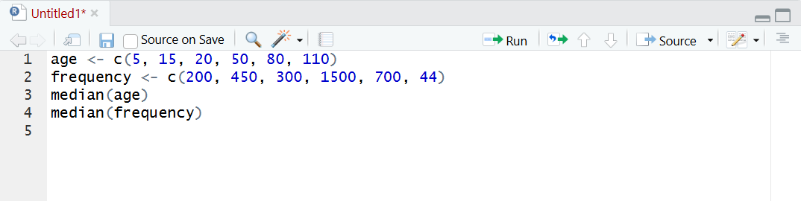
Output
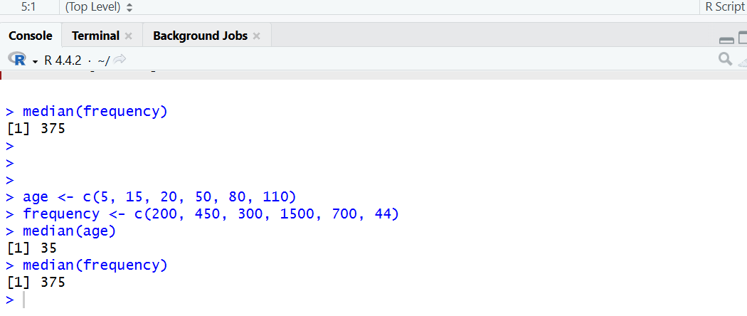

Result: It is executed successfully.

Experiment-2
Aim: To find the data for analysis includes the attribute age.
Program
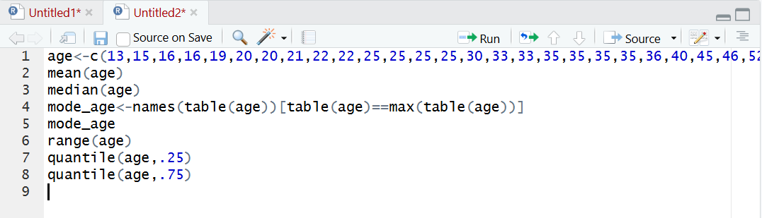
Output
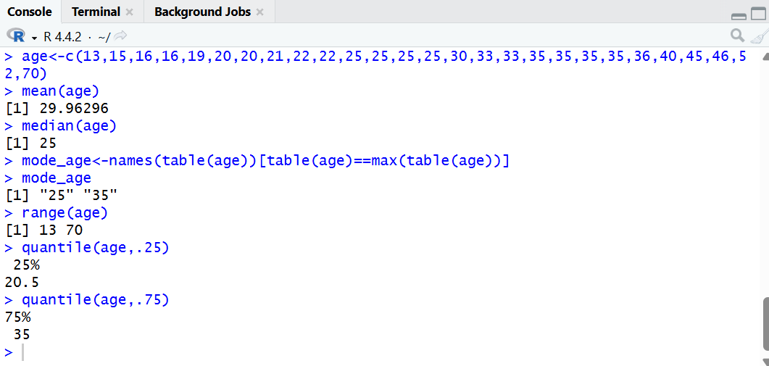
Result: It is executed successfully.

Experiment-3
Aim: To show Data Preprocessing IN Reduction and Transformation.
Program
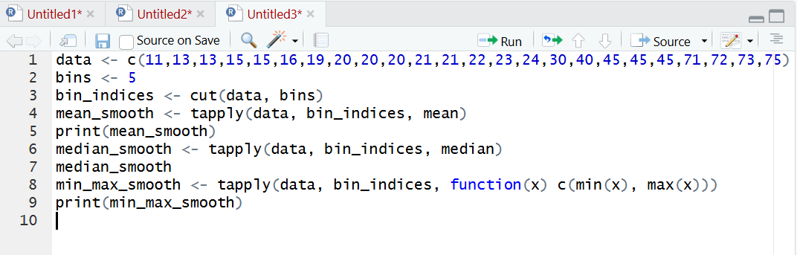
Output
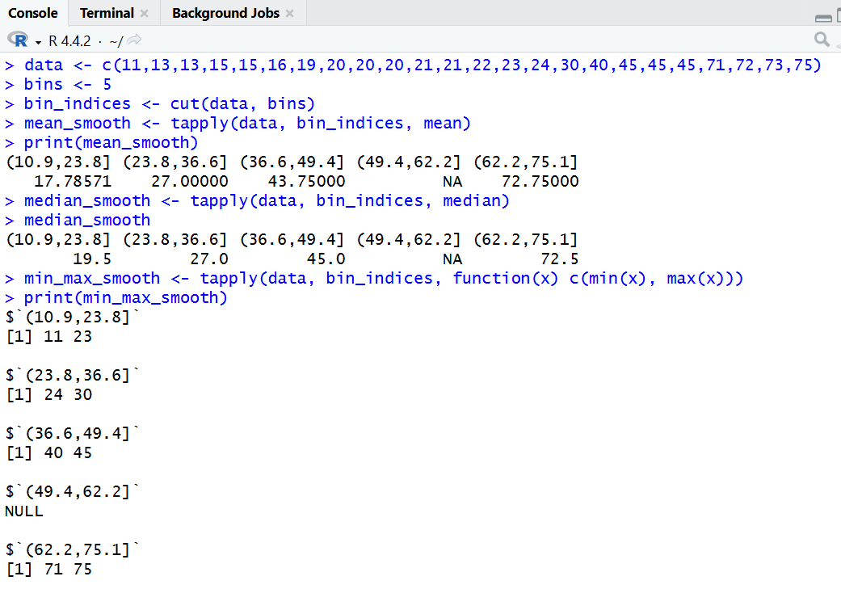
Result: It is executed successfully.

